Beyond Textual Chain-of-Thought: Observing and Visualizing Multimodal Reasoning
An evidence-based research and implementation whitepaper
Nathan Conklin
nathan.conklin@vt.edu
Department of Computer Science,
Virginia Tech

Abstract
Most reasoning interfaces present a language model's work as a text transcript. That design is convenient for software developers, but it does not represent the full range of intermediate artifacts that multimodal systems can produce. Recent research has demonstrated reasoning workflows that use sketches, diagrams, image edits, and learned visual representations. At the same time, commercial APIs have begun exposing structured reasoning summaries and intermediate image artifacts. This paper examines the evidence for visual chain-of-thought (VCoT), distinguishes visible reasoning artifacts from hidden model computation, and identifies a concrete opportunity for human-computer interaction research: an interface that aligns textual summaries, intermediate images, tool execution, and final responses in one inspectable timeline. Google's Gemini Interactions API offers a practical starting point because it returns ordered thought steps and, for supported image-generation tasks, image content inside thought summaries. The paper includes a proposed software architecture, a Python capture example, an evaluation plan, and limits on what can be inferred from an API trace. The central claim is that multimodal reasoning observability is technically feasible today, although exposing intermediate artifacts does not establish complete access to a model's internal reasoning.

1. The Research Question
The immediate question came out of a live discussion with the AI Decoded group on October 8, 2026. The initial work concerned extracting reasoning text and creating interfaces that help a human follow an AI system's progress. The discussion then broadened: people reason with diagrams, spatial imagination, sounds, language, and changing mental representations. Models that process multiple modalities may also produce useful intermediate visual artifacts. A text-only interface can omit those artifacts or force them into an inadequate description.
That observation leads to two related research questions. First, can a model use a visual intermediate representation to improve its task performance? Second, can an API provide enough of that representation for a person to inspect, compare, or redirect the process? These questions require different evidence. Improvements in model benchmark accuracy do not demonstrate that a visualization will help a person. Likewise, a thought image that appears in an API response does not establish that a complete internal cognitive state has been exposed.
This whitepaper treats the human-facing problem as an opportunity in information visualization and human-AI collaboration. The objective is to create an observable reasoning workspace that combines evidence of the model's actions with interpretive visualizations. The workspace should preserve uncertainty about what each visible element represents.

2. Terminology: Four Different Kinds of Reasoning Representation
Several phenomena are called "visual chain-of-thought" in the literature and in product documentation. A research interface should distinguish them.
Textual chain-of-thought summaries are natural-language descriptions of planning or intermediate work. Provider-generated summaries are selected or transformed accounts of reasoning, rather than a complete stream of internal reasoning tokens. OpenAI's Responses API documents reasoning summaries while explicitly withholding raw reasoning tokens (OpenAI, 2026). Google's thought steps similarly provide optional summaries and a separate cryptographic signature (Google, 2026a).
External visual reasoning artifacts are drawings, annotations, rendered graphs, or image transformations that a model creates through a tool or output channel. Their pixels can be stored, replayed, and evaluated. Visual Sketchpad illustrates this class: a model uses actions such as drawing boxes or auxiliary lines to support visual problem solving (Hu et al., 2024).
Intrinsic image-based reasoning outputs occur when a multimodal model generates or edits intermediate images as part of its own task sequence. MathCanvas trains a model to use interleaved text and diagrams when solving mathematical problems (Shi et al., 2026). Google's image-generation documentation describes interim thought images that can appear in the response of supported Gemini image models (Google, 2026b).
Latent visual reasoning representations are internal learned states or visual tokens that participate in a model's computation. Li et al. (2025) study autoregressive reasoning in a visual embedding space. These representations are important to model research, but there is no basis for treating a typical commercial API's thought-summary image as a direct visualization of all latent states.
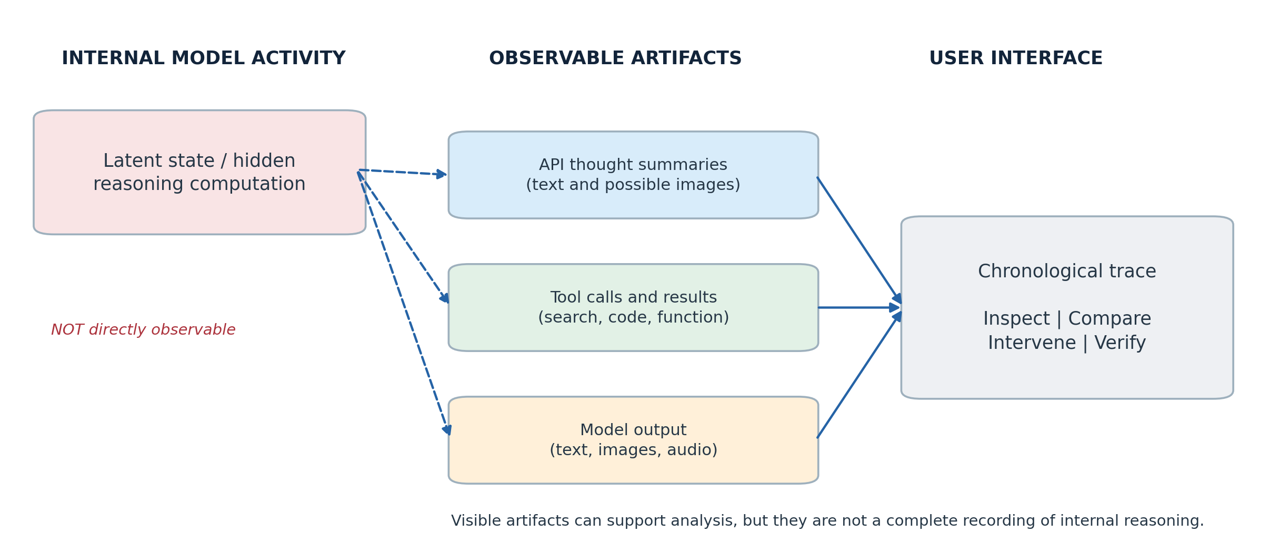
Figure 1: Figure 1. Evidence layers: hidden model computation, observable API artifacts, and the interface shown to a person.
The practical distinction is one of provenance. A visual component may be directly emitted by the model, produced by a drawing tool, inferred from telemetry, or generated afterward by a visualization algorithm. Those origins should remain visible in the interface.

3. Evidence from Visual Reasoning Research

3.1 Visual Sketchpad: Drawing as a Reasoning Tool
Hu et al. (2024) introduced Visual Sketchpad: Sketching as a Visual Chain of Thought for Multimodal Language Models. The approach gives a model drawing actions such as lines, marks, and bounding boxes, allowing the model to examine its own visual edits. The authors report average gains of 12.7% on mathematical tasks and 8.6% on visual tasks relative to their tested baselines. These are results for the authors' task selection and experimental configuration, rather than a general estimate for all models (Hu et al., 2024).
Visual Sketchpad establishes that intermediate visual actions can be useful computational work. It also provides an interface-oriented clue: every drawing command can become a distinct observable event. A human could replay the sequence, inspect the annotations, and compare the model's marked-up evidence against the original image. This makes Sketchpad relevant even though its original preprint dates to 2024.

3.2 MIRA: Evaluating the Value of Intermediate Images
When Visualizing is the First Step to Reasoning: MIRA, a Benchmark for Visual Chain-of-Thought, by Zhou et al., was posted as a preprint in November 2025. MIRA contains 546 multimodal problems with associated intermediate visual clues and answers. Its evaluation compares direct input, text-based chain-of-thought, and conditions with intermediate visual clues. The paper reports an average relative performance gain of 33.7% when models receive the annotated visual cues, across its models and tasks (Zhou et al., 2025).
MIRA matters because it isolates a failure of language-only scaffolding in problems where geometry, structure, or spatial change is hard to express in words. The result supports the utility of visual information during problem solving. It does not demonstrate that all evaluated models can independently generate the necessary images on demand. In particular, performance with curated visual hints should not be equated with performance when the system must discover, draw, and validate its own hints.
A human-facing extension would display the visual clue adjacent to the textual claim it supports, then record whether the user catches a mistaken diagram or can supply a more useful one. MIRA provides tasks suitable for such evaluation, although a human study would need a distinct protocol from the model benchmark.

3.3 MathCanvas: Model-Generated, Interleaved Visual Reasoning
Shi et al.'s MathCanvas: Intrinsic Visual Chain-of-Thought for Multimodal Mathematical Reasoning appeared at ACL 2026. The work separates training for visual manipulation from training for strategic use of visual aids. The authors describe 15.2 million pretraining pairs, 219,000 interleaved reasoning examples, and a 3,000-problem benchmark. Their BAGEL-Canvas model achieves an 86% relative improvement over tested strong multimodal baselines on MathCanvas-Bench (Shi et al., 2026). This figure is a relative performance improvement within the paper's benchmark and must not be presented as an 86-percentage-point gain or a universal improvement.
The interaction lesson is that an intermediate image may appear when a reasoning strategy calls for it. A visualization that forces every step into a picture could become as misleading as a text-only interface. A useful workspace should support modality-specific steps and permit gaps when there is no visual artifact.

3.4 Text-Based Reasoning Can Impair Spatial Performance
Kancheti, Kanade, Balasubramanian, and Ganu (2026), in Chain-of-Thought Degrades Visual Spatial Reasoning Capabilities of Multimodal LLMs, evaluated 16 models on 13 spatial benchmarks in the ACL-published version. The authors report that text-based chain-of-thought prompting consistently degraded performance on the evaluated visual-spatial tasks. Their No-Image++ ablation also found cases in which models relied on textual priors and hallucinated visual details without the image (Kancheti et al., 2026). A related preprint abstract refers to 17 models; the published ACL record is used here because it is the definitive citation for this paper.
This is evidence against assuming that additional textual reasoning always improves visual tasks. It does not imply that textual reasoning is generally harmful or that thought images alone guarantee accurate spatial judgments. The research motivates interfaces that retain direct access to the image and provide ways to compare textual statements with image evidence.

3.5 Latent Visual Reasoning and a Broader Research Direction
Li et al. (2025) study reasoning in visual embedding space. Their approach generates latent visual states alongside ordinary text generation; they report 71.67% on MMVP compared with 66.67% for their cited Qwen2.5-VL baseline. The model's hidden representations remain a different object from a rendered picture that an application can display. Su et al. (2025) survey "thinking with images," organizing approaches across external tools, programmatic visual manipulation, and intrinsic imagination. Together, these papers support treating visual reasoning as a family of methods, rather than as a single API feature.

3.6 Comparative Evidence
Work | Year / status | Intermediate representation | Reported result | Relevance to interface research
Visual Sketchpad (Hu et al.) | 2024 preprint | Tool-generated sketches and marks | 12.7% average math gain, 8.6% visual-task gain | Drawing actions are traceable and replayable
MIRA (Zhou et al.) | 2025 preprint | Curated intermediate visual clues | 33.7% average relative gain in its visual-clue condition | Isolates information lost with text-only prompting
MathCanvas (Shi et al.) | ACL 2026 | Generated and edited diagrams interleaved with text | 86% relative improvement on MathCanvas-Bench | Supports image events within a reasoning sequence
Kancheti et al. | ACL 2026 | Comparison of text CoT with visual-spatial tasks | Text CoT degraded performance on tested tasks | Warns against substituting prose for visual evidence
Latent Visual Reasoning (Li et al.) | 2025 preprint | Internal visual embedding tokens | 71.67% vs 66.67% on MMVP in reported setup | Highlights the limits of external inspection

Table 1. Results differ in metrics, benchmarks, baselines, and experimental designs. They should not be ranked against one another as comparable effect sizes.

4. Available API Surface: What Can Be Retrieved Today?

4.1 Gemini Interactions API
Google's Interactions API represents a model exchange as an ordered set of execution steps. Documentation shows thought, function_call, function_result, google_search_call, google_search_result, and model_output step types where applicable (Google, 2026a; Google, 2026c). For a thinking model, a thought step contains a required encrypted signature and an optional summary. Summary blocks may contain text or image; some thought steps have no summary.
For supported Gemini image-generation models, Google's documentation states that reasoning can include interim images used for composition and logic. The image-generation page documents up to two interim images and shows code that reads image blocks within thought-step summaries (Google, 2026b). This is an unusually useful feature for investigating visual artifacts in a commercial system. Availability depends on model, task, configuration, and actual model behavior; developers should expect some requests to return no intermediate image.
The API endpoint is:
POST https://generativelanguage.googleapis.com/v1beta/interactions
x-goog-api-key: $GEMINI_API_KEY
Content-Type: application/json

A documented request shape is:
{
"model": "gemini-nano-banana-2.1",
"input": "Draw and explain a bicycle gear-shift mechanism.",
"generation_config": {
"thinking_summaries": "auto"
}
}

The following response shows the conceptual structure. It is intentionally schematic; field contents, the number of steps, and the existence of thought images vary between calls.
{
"steps": [
{"type": "thought", "signature": "...", "summary": [
{"type": "text", "text": "[model-supplied summary]"},
{"type": "image", "data": "[base64 encoded image]"}
]},
{"type": "model_output", "content": [
{"type": "image", "data": "[base64 encoded final image]"}
]}
]
}

The signature should be retained as provided when a client continues a stateless exchange, but it is an encrypted continuation artifact, not interpretable evidence for a user. An application should display a label such as "model-provided reasoning summary" for the readable material. Claims of exposing the full model reasoning are not supported by the published API description.

4.2 Python: Capture Thought Images and Final Output
The following example uses the documented Google Gen AI SDK objects. It saves actual image content based on the image's detected format. Because this whitepaper was produced without calling a credentialed Gemini account, the example has been checked against the documentation but has not been tested end-to-end with a live API response.
pip install -U google-genai pillow
# Set GEMINI_API_KEY in the environment before running.

from google import genai
from PIL import Image
from pathlib import Path
import base64
import io
import json

client = genai.Client()
out = Path("captured_trace")
out.mkdir(exist_ok=True)

interaction = client.interactions.create(
model="gemini-nano-banana-2.1",
input="Create and explain a labeled bicycle gear-shift diagram.",
generation_config={"thinking_summaries": "auto"},
)

events = []
for step_index, step in enumerate(interaction.steps or []):
kind = step.type
blocks = (
(step.summary or []) if kind == "thought" else
(step.content or []) if kind == "model_output" else []
)
for block_index, block in enumerate(blocks):
record = {"step": step_index, "kind": kind,
"block": block_index, "modality": block.type}
if block.type == "text":
record["text"] = block.text
elif block.type == "image" and block.data:
raw = base64.b64decode(block.data)
im = Image.open(io.BytesIO(raw))
suffix = ".png" if im.format == "PNG" else ".jpg"
path = out / f"{kind}_{step_index}_{block_index}{suffix}"
path.write_bytes(raw)
record["path"] = str(path)
events.append(record)

(out / "events.json").write_text(json.dumps(events, indent=2))
print("Captured", len(events), "content blocks")

The example captures readable text and image blocks. A production logger should additionally record all step types, step identifiers, tool arguments/results where permitted, event arrival times, model version, request settings, and error states. It should avoid storing secrets or sensitive prompts in a public trace.
[TODO: Run this example with an authorized Gemini API key, record the exact SDK and model versions, and confirm which requests return thought images. The documentation supports this capability, but this whitepaper does not claim an observed successful test.]

4.3 Streaming and Synchronization
Google documents server-sent events (SSE) for the Interactions API. Thought summaries may arrive as thought_summary deltas, and signatures as distinct thought_signature deltas before a step stops (Google, 2026a). A user interface can use these events to update a trace as work proceeds. Network arrival time, however, is not a direct measure of when the model formed an internal representation. The interface should label observed event times as API receipt or step order rather than cognitive time.
The processing path can be implemented in two passes. First, capture complete responses and validate how each content block maps to a persisted artifact. Second, add streaming and show partial steps only after the event parser handles reorderings, absent summaries, and incomplete interactions. Historical replay should produce the same user-visible ordering as the original captured sequence.

4.4 Comparison with Other Providers
OpenAI's public reasoning documentation describes reasoning summaries in reasoning output items, rather than raw reasoning tokens (OpenAI, 2026). Anthropic documents summarized extended thinking for supported Claude models, and its documentation distinguishes that summary from full thinking (Anthropic, 2026). Those services may produce visual outputs or tool execution logs, but the documentation reviewed for this paper does not establish a general-purpose API that exposes internal visual states in the same form as Gemini image-model thought images.
Provider / interface | Reasoning text exposed | Intermediate thought images | Execution events | Interpretive limit
Gemini Interactions API | Optional thought summaries | Documented for supported image models | Chronological steps and SSE | Summaries and images are partial observable artifacts
OpenAI Responses API | Opt-in reasoning summaries | No equivalent general capability established in cited documentation | Tool items and output events vary by model | Raw reasoning tokens are not exposed
Anthropic Messages API | Summarized thinking on supported models | No equivalent general capability established in cited documentation | Tool-use blocks and streams | Full internal thinking is not provided through ordinary summary output

Table 2. Public documentation review as of October 8, 2026. Product behavior and model availability may change.

5. Proposed Multimodal Reasoning Workspace
The research opportunity is to place every observable step into one coordinated interface. A practical design would retain the conversational history on the left and use a synchronized reasoning timeline on the right. Each event would show its modality and evidence source. Thought-summary text, intermediate image thumbnails, external tool outputs, and final answer blocks could be expanded together or viewed as a paired text-and-image sequence.
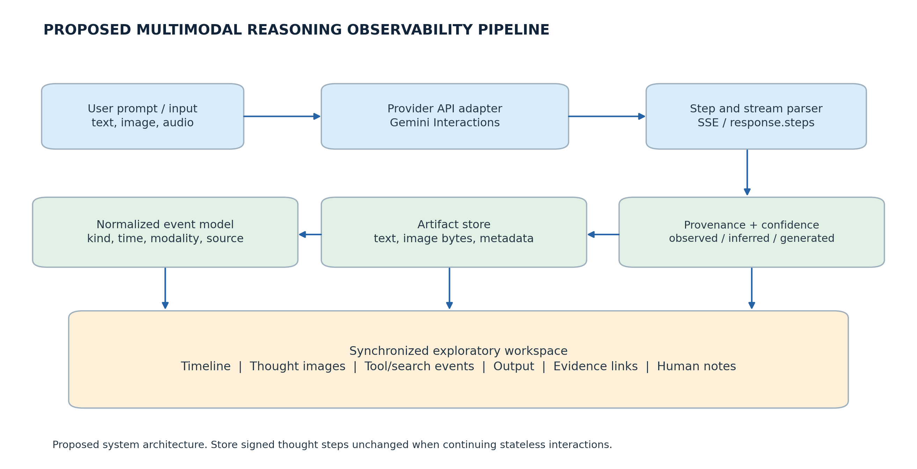
Figure 2: Figure 2. Proposed event-capture and visualization architecture for multimodal reasoning observability.

5.1 Event Schema and Provenance
A provider-neutral event record can preserve enough metadata for later replay and comparison:
{
"event_id": "interaction-001:step-003:block-002",
"sequence_index": 3,
"event_kind": "thought_summary",
"modality": "image",
"source_type": "provider_returned",
"provider": "google",
"model": "gemini-nano-banana-2.1",
"received_at": "2026-10-08T18:00:00Z",
"artifact_uri": "artifacts/step-003-image-002.png",
"parent_event_id": "interaction-001:step-003",
"visibility_note": "Observable summary artifact, not raw model state"
}

This is a proposed local schema, not a Gemini wire-format object. Four source labels would prevent overclaiming: provider_returned, tool_generated, ui_inferred, and human_authored. An application-generated diagram that summarizes a text paragraph should carry ui_inferred, even when it looks like a model's own thought image. The labeling protects experimental validity because users could otherwise mistake an explanatory visualization for an observed model action.

5.2 Views and User Actions
The initial interface should support a chronological overview, a detail panel, and a comparison view. The overview shows step order, duration as observed by the client, modality, tool calls, and the relationship between an image and adjacent text. The detail panel shows full-resolution media alongside its source and timestamp. The comparison view allows a person to place two steps or two model runs side by side.
Human intervention is a separate capability from observation. A person might mark an incorrect geometry line, attach a corrected diagram, or ask the model to reconsider a conclusion using a cited visual. The interface should record that action as a new human-authored event; it should not silently rewrite earlier provider-returned steps. If the application re-issues a model request, the trace should retain the original prompt and response for a valid before-and-after comparison.

5.3 Evidence and Confidence
A confidence display requires care. Providers do not generally return calibrated per-step probabilities for visual reasoning summaries. The interface should therefore distinguish confidence in the source of the artifact from confidence in the correctness of a claim. For example, a screenshot may be verifiably returned by an API while the diagram itself remains incorrect. A useful early implementation can show provenance and verification status without inventing a numerical certainty score.

6. A Research and Engineering Evaluation Plan
An initial study can compare interface conditions without requiring access to hidden model reasoning. The experimental manipulation should be the information available to the human operator, with the underlying model prompts and tasks held constant where possible.
Condition A: Text only. Show the prompt, final answer, and any available textual reasoning summary. Condition B: Text plus execution. Add chronological tool calls and results. Condition C: Multimodal trace. Add returned intermediate images, their source metadata, and step-aligned image/text inspection. An optional Condition D could permit human annotation and follow-up requests.
Candidate tasks include spatial puzzles from MIRA, diagram-based mathematics inspired by MathCanvas, and image-grounded problems with objective answers. Since image artifacts may be absent, the study must count the fraction of tasks that produced usable visual events. It should not treat a lack of events as a UI rendering failure when the API itself returned no intermediate visual content.
A lightweight agentic evaluation can measure trace completeness, correct association of image and text blocks, replay determinism, logging overhead, and event loss under streaming. A later human study can measure error detection, time to verification, localization of the evidence supporting an answer, and the frequency of inappropriate trust in misleading intermediate images. Participants should be able to report uncertainty; a faster response that confidently accepts a wrong diagram is not an improvement.
A useful ablation would show an accurate final answer paired with a misleading intermediate image, then reverse the condition. This tests whether humans overweight vivid intermediate artifacts. The study should clearly disclose that the visible artifacts are selected summaries rather than a transparent transcript of all internal reasoning.

7. Limitations and Open Questions
Three limitations affect the proposed system. First, observability is incomplete. Provider summaries are curated and may omit important internal processing. Latent visual tokens are not generally recoverable through ordinary image-generation response fields. Second, visual artifacts can be wrong. A generated diagram might look coherent while encoding an incorrect spatial relationship. Third, observing process is not equivalent to understanding causality. Chronological adjacency between a thought image and a final answer does not prove that a particular image caused the answer.
The voice demonstration raised the parallel possibility of auditory reasoning. Multimodal models can consume and produce audio, but this paper found no comparably documented, general-purpose commercial API exposing a complete intermediate auditory reasoning trace. The first implementation should focus on text, images, and tool execution, then extend to audio if a specific provider exposes suitable intermediate artifacts. Any audio waveform generated as a final response should remain labeled as output rather than evidence of hidden auditory deliberation.
Finally, the research must distinguish the model-performance question from the human-interface question. MIRA and MathCanvas offer evidence about task-solving methods. The proposed interface still needs evaluation showing that displaying intermediate visuals helps a human notice errors, establish provenance, or make decisions. Such benefits are hypotheses, not findings of the cited model benchmarks.

8. Conclusions and Immediate Next Steps
Visual chain-of-thought is an active technical area with concrete experimental results and at least one commercially documented route to intermediate image artifacts. MIRA provides evidence that intermediate visual clues can improve difficult visual reasoning tasks. MathCanvas shows that a model can be trained to generate and edit diagrams while solving problems. The ACL 2026 study by Kancheti et al. adds a warning: more textual chain-of-thought is not automatically better for spatial understanding. Google's Interactions API then creates a practical opportunity to capture text summaries, thought images when produced, and execution steps in one event stream.
The recommended first prototype is a capture-and-replay tool for Gemini image-generation interactions. It should preserve each returned step, save images as original bytes, record tool events, and display a chronological multimodal timeline with explicit provenance labels. Once the capture process has been validated against real responses, the next increment should add comparison and human intervention. That development path would turn a research idea raised during a live conversation into a testable HCI system without misrepresenting API summaries as the model's complete internal reasoning.

References
Anthropic. (2026). Extended thinking. Claude Platform documentation. https://platform.claude.com/docs/en/docs/build-with-claude/extended-thinking
Google. (2026a). Gemini thinking. Google AI for Developers. https://ai.google.dev/gemini-api/docs/thinking
Google. (2026b). Gemini API: Image generation. Google AI for Developers. https://ai.google.dev/gemini-api/docs/image-generation
Google. (2026c). Interactions API overview. Google AI for Developers. https://ai.google.dev/gemini-api/docs/interactions-overview
Hu, Y., Shi, W., Fu, X., Roth, D., Ostendorf, M., Zettlemoyer, L., Smith, N. A., & Krishna, R. (2024). Visual Sketchpad: Sketching as a Visual Chain of Thought for Multimodal Language Models. arXiv:2406.09403. https://arxiv.org/abs/2406.09403
Kancheti, S. S., Kanade, A. S., Balasubramanian, V. N., & Ganu, T. (2026). Chain-of-Thought Degrades Visual Spatial Reasoning Capabilities of Multimodal LLMs. Proceedings of the 64th Annual Meeting of the Association for Computational Linguistics (Volume 2: Short Papers), 862–876. https://doi.org/10.18653/v1/2026.acl-short.71
Li, B., Sun, X., Liu, J., Wang, Z., Wu, J., Yu, X., Chen, H., Barsoum, E., Chen, M., & Liu, Z. (2025). Latent Visual Reasoning. arXiv:2509.24251. https://arxiv.org/abs/2509.24251
OpenAI. (2026). Reasoning models. OpenAI API documentation. https://developers.openai.com/api/docs/guides/reasoning
Shi, W., Yu, A., Fang, R., Ren, H., Wang, K., Zhou, A., Tian, C., Fu, X., Hu, Y., Lu, Z., Huang, L., Liu, S., Liu, R., & Li, H. (2026). MathCanvas: Intrinsic Visual Chain-of-Thought for Multimodal Mathematical Reasoning. Proceedings of the 64th Annual Meeting of the Association for Computational Linguistics (Volume 1: Long Papers), 27933–27954. https://doi.org/10.18653/v1/2026.acl-long.1287
Su, Z., Xia, P., Guo, H., Liu, Z., Ma, Y., Qu, X., Liu, J., Li, Y., Zeng, K., Yang, Z., Li, L., Cheng, Y., Ji, H., He, J., & Fung, Y. R. (2025). Thinking with Images for Multimodal Reasoning: Foundations, Methods, and Future Frontiers. arXiv:2506.23918. https://arxiv.org/abs/2506.23918
Zhou, Y., Tu, H., Wang, Z., Wang, Z., Muennighoff, N., Nie, F., Choi, Y., Zou, J., Deng, C., Yan, S., Fan, H., Xie, C., Yao, H., & Ye, Q. (2025). When Visualizing is the First Step to Reasoning: MIRA, a Benchmark for Visual Chain-of-Thought. arXiv:2511.02779. https://arxiv.org/abs/2511.02779

